## 

**Book->Chapter->Module->Assignment->Brix** **2**

**Do not make copies of entire assignments / modules / titles** **2**

**How to find an item on MyProgrammingLab** **2**

**Code Question Brix** **6**

**Simple Code Question Brix** **8**

**Live Example Brix** **11**

## 

## 

## 

## 

## Book->Chapter->Module->Assignment->Brix

Every new CS title should be created using the structure similar to GUID 221214e3-7450-46e4-8e0c-179e9715aed7

Refer Nemo Help for information on how to create a book structure.

## Do not make copies of entire assignments / modules / titles

Sometimes a new revision of a title will be 80% similar to the old revision. As tempting as it is to just make a copy of the title and make changes where required, this should **not** be done. This is because we do not want multiple copies on Nemo.

If any Quiz can be reused, it’s fine to reuse it. Create a new module and use the old Quiz’s GUID wherever applicable.

## How to find an item on MyProgrammingLab

1. Login to myprogramminglab
2. Open the course where the item is. For example, if you are working on Gaddis C++, open the Gaddis C++ course
3. Go to Table of Contents and click on Go To Exercise

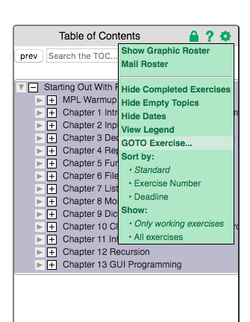

1. Hover around an item to see its full exercise number.

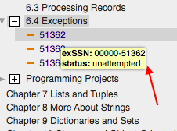

1. This where you will see the correct solution

## 

1. Only copy “our solution”
2. If there are 2 “our solutions” include both on Nemo

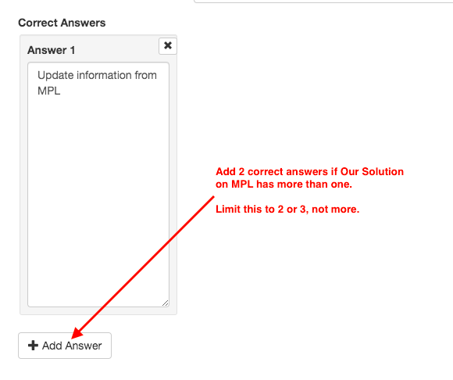

## 

## Code Question Brix

To add a Code Question Brix to a quiz, first search for the existence of the Brix on Nemo. For example, if you want to add MPL question 20678 to a quiz, search for 20678.

If it exists, it will show up as “exercise-00000-20678.json”. If there are multiple copies of this item, use the latest copy.

If it doesn’t exist, then create it. In order to create it:

1. Make a copy of this item: 9ed6ba16-a669-4e20-a805-cb32a5e796d0
2. Change the following

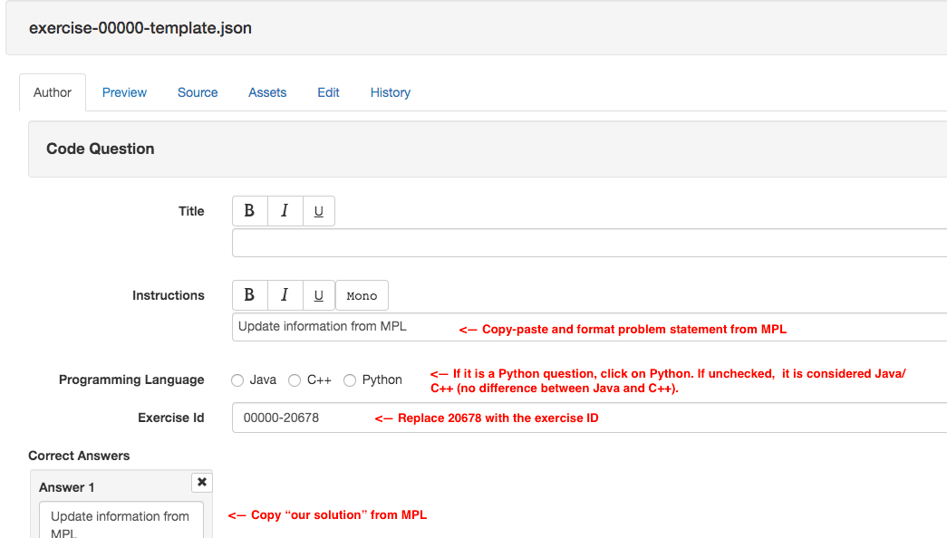

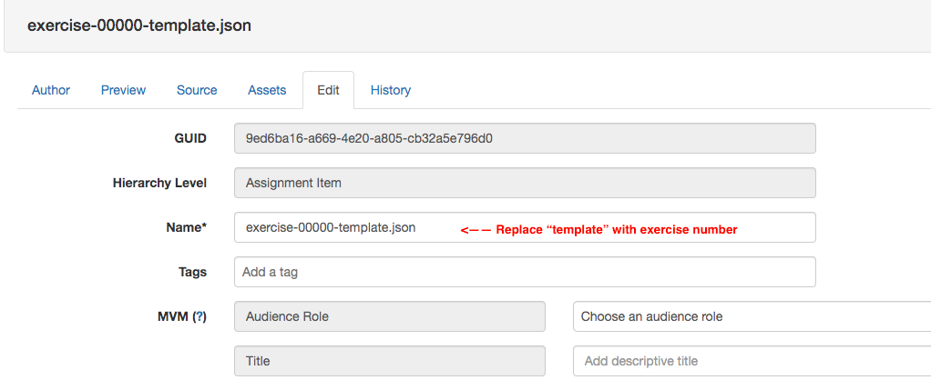

1. Please note that hitting the submit button on Nemo in the Preview mode is not going to give you a correct response. This is just UX, it is not connected to the answer engine. In order to test, you have to test it on Revel.

## 

## Simple Code Question Brix

1.Make a copy of this item: 4701cee7-73cb-468e-b155-a91b38fa6a21

2. Change the following:

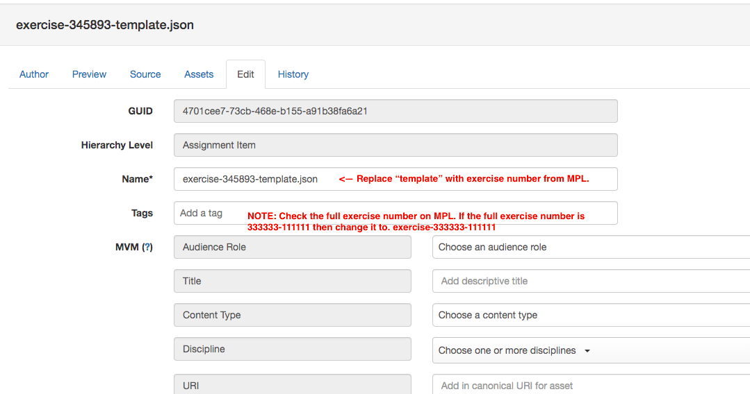

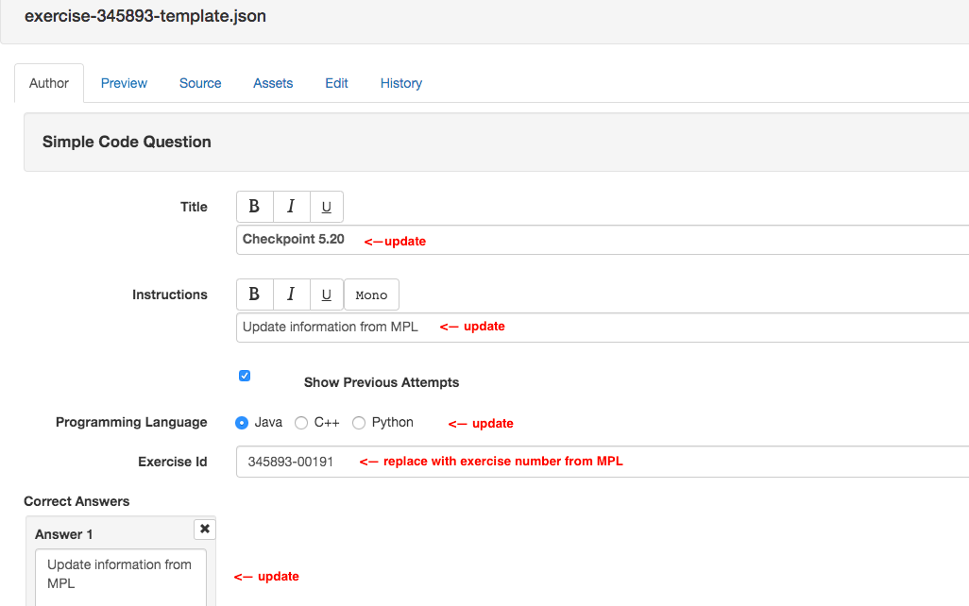

3. Please note that hitting the submit button on Nemo in the Preview mode is not going to give you a correct response. This is just UX, it is not connected to the answer engine. In order to test, you have to test it on Revel.

4. Please note that while Code Question and Simple Code look alike on the Nemo side, they are different. Make sure you use the correct assignment type. A quick check for that is to see what is displayed in Author tab. See below.

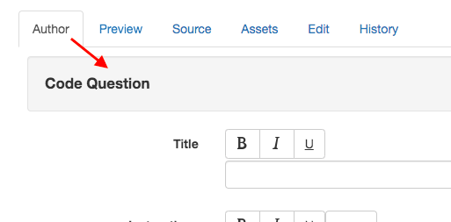

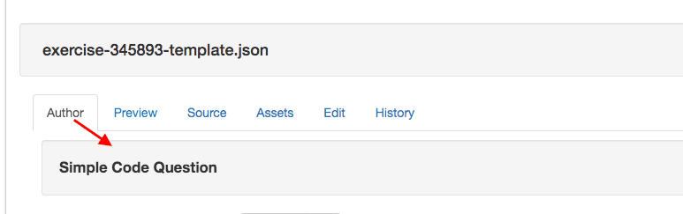

5. Please note that Simple Code on MyProgrammingLab has exercise IDs that don’t begin with “00000”

See below for a Simple Code Question

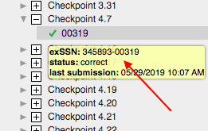

See below for a Code Question



## 

## Live Example Brix

Have a look at the Live Example Brix in the title:

221214e3-7450-46e4-8e0c-179e9715aed7 (java)

d8dc7f56-67f7-4cd9-968f-7199e1efcf61 (python)

F2f24cc0-d872-48dd-8d16-543b7128e9ab (c++)

Make a copy of a Live Example Brix

Change the following:

1. Programming Language and Version
2. Exercise Instruction
3. Source file name and executable file name (note how it’s names in java, python, c++ respectively)
4. Initial Code
5. Initial Cursor Position -- If the exercise instruction states “Change line 15” then place the cursor in line 15. If instruction doesn’t call out any particular line, then let the default remain.
6. Lines to Display -- Try to make the minimum lines just 2 to 3 lines greater than the maximum number of lines *provided* the maximum lines is around 25. That is, don’t make the minimum lines greater than 25 at all. This is because we want the Brix to fix on the screen, it’s ok if the student has to scroll. The Python titles have min/max lines done accurately -- if you have any doubts, check the Python title and see how it’s done there.
7. Answer
8. Unlike Code Question Brix and Simple Code Question Brix, with this Brix you can check if it works. After coding the problem, go to Preview mode, click “Answer” and submit. Every item you code should compile without any errors when you hit Answer.